The M&C Saatchi Merlin website captures the energy and dynamism of the creative talent agency. The design is vibrant and reflects their high-energy approach. The website effectively communicates their brand values and engages users with dynamic visuals and easy navigation.
Scrolling typography adds a stylish touch and an integrated Instagram feed keeps the content lively and up-to-date.
Key Highlights:
- Strong Branding: Clear and consistent.
- Video Content: Plenty of engaging videos.
- User-Friendly: Easy to navigate.
- Modern Design: Fresh, broken grid layout.
- Efficient Performance: Lazy loading for quick access.
- Scrolling Typography: Adds style.
- Social Integration: Instagram feed.

This website highlights the impact of human activities on the oceans. It uses custom illustrations and a strong color scheme of black, dark blue, and dark magenta to create a sense of urgency. The scrolling experience is designed to show the problem visually rather than just telling about it, making it more impactful. The strong message and graphics emphasize the need for ocean conservation.
Key Highlights:
- Custom Illustrations: Unique and detailed.
- Urgent Colors: Black, dark blue, and dark magenta.
- Visual Storytelling: Shows the problem through scrolling.
- Strong Message: Emphasizes ocean conservation.

White Coffee, a Paris-based specialty coffee brand, has a sleek and minimalist website. The site features big, bold titles and video presentations, organized in a multi-column grid. Lazy loading improves performance, and ample white space gives it a clean look. Hover effects on products, a parallax gallery section, and multiple call-to-action options make the site engaging and interactive.

Key Highlights:
- Minimalist Design: Clean and sharp with white space.
- Bold Titles: Easy to read and eye-catching.
- Video Content: Engaging presentations.
- Organized Layout: Multi-column grid.
- Smooth Performance: Lazy loading.
- Interactive Elements: Hover effects and parallax gallery.
- Engaging CTAs: Multiple call-to-action options.

Educature is a special website template for online courses and academies. What we dig about it the most is its versatility.
You can use Educature for courses, sports, dance, football, language, yoga, whatever!
In other words, you can use it for niche or general academy and educational platforms.
With a focus on online education.
Educature is also EASY to work with, so turning it from an HTML template to an actual website will be a little breeze.
But if you ever face any hiccups, reach out to the epic support team or read through the documentation.
It’s possible! You only need access to Educature.
Educature features:
- Go niche or go general
- Unique back to top button
- Bold search function above the fold
- Top course categories
- Newsletter subscription form

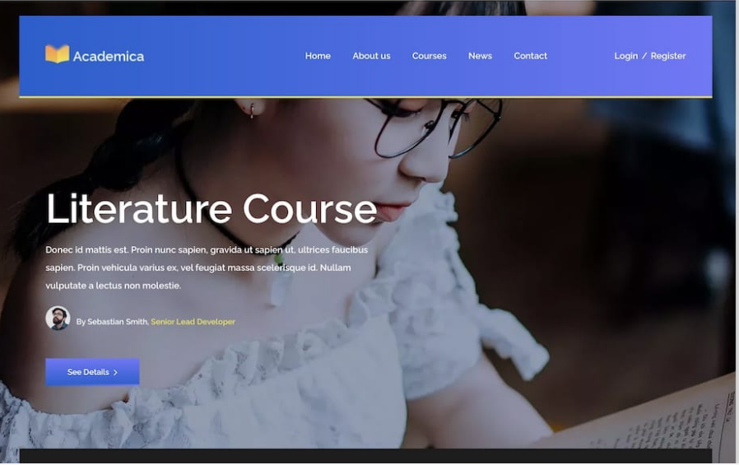
You will experience exceptional mobile and desktop experience with Academica. This academy website template knows no bounds.
It unlocks the extraordinary potential you deserve.
Whether you’re building an educational page for yourself or your client (or both!), do it with Academica.
You can easily use Academica for different academy projects if you are more code-savvy.
No one will tell!
You can feature the most popular course on the front page, above the fold, but let students use the advanced course search function for quick finds.
Also, don’t miss adding different milestones, acting as great persuading factors.
Academica features:
- Featured course(s)
- Call-to-action (CTA) buttons
- Detailed courses search
- Pricing plans (w/ montly & annual toggle)
- Contact page (form & map)

